Implementing Ecological Models on GPU

At the Netherlands Institute for Sea Research – Yerseke campus.
Contact person: Johan van de Koppel (johan.van.de.koppel@nioz.nl)

The NIOZ is looking for a dedicated student for the following internship/ MSc-Thesis project.

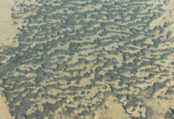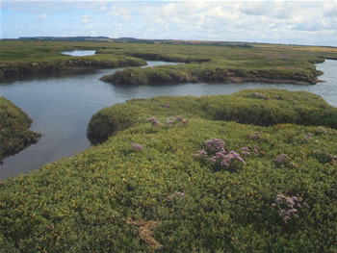

Modelling of the functioning of ecosystems not only requires the inclusion of biological processes such as organism growth, but also of physical processes such as water flow and wave action. Typically, however, these processes operate on vastly different timescales, where biological population change at timescales of days, months or even years, while physical processes such as tidal water flow occurs at timescales of seconds. Linking these two processes remains a formidable computational challenge, and precludes flexible simulation of for instance salt marsh or mussel bed dynamics.

In the project, we aim to accelerate bio-physical models of ecosystems using GP-GPU techniques. Using CUDA or OpenCL, you will be combining hydrodynamic models with biological models of patterns formation in mussel beds and other patterned system in estuaries, or models to study how plant-water flow dynamics determine salt marsh development.

Further inquiries: johan.van.de.koppel@nioz.nl

