MSc-project proposal

Efficient solution of Poisson’s equation by the variational collocation method using dataflow computing




Introduction
Many practical engineering problems require the accurate and computationally efficient solution of partial differential equations (PDEs) by means of numerical discretization and solution methods. A very recent discretization approach is isogeometric analysis (IgA) [Hu05], which is an extension of the Finite Element Method (FEM). In essence, IgA adopts the same mathematical tools, namely, high-order B-Spline basis functions, to parameterize the problem geometry and to approximate the numerical solution. Since B-Splines and NURBS (non-uniform rational B-Splines) are the de-factor standard for describing complex geometries in Computer-Aided Design (CAD) programs, IgA is particularly useful for solving PDE-problems coming from industrial applications.
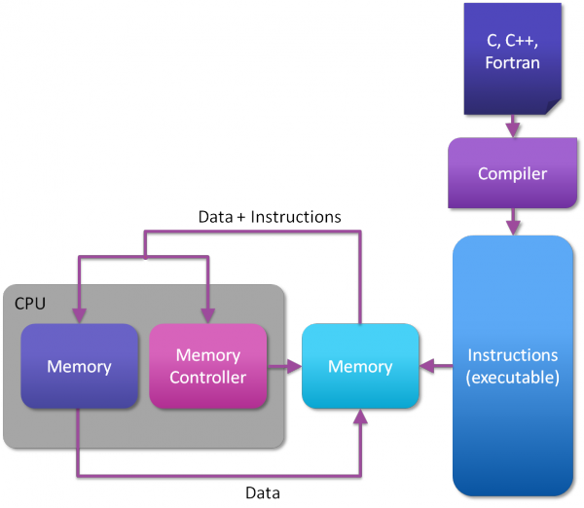
In practice, the numerical computation of approximate solutions is very time consuming due to the large number of degrees of freedom (dofs) that are necessary to achieve sufficient accuracy. It is nowadays common practice in high-performance computing is to use processors with multiple compute cores (multicore CPUs) and accelerate the most expensive parts of the simulation by using accelerator cards (e.g. programmable Graphics Processing Units (GPUs)). All these compute devices are based on the control-flow computing paradigm. As depicted in the figure on the right, the program source is transformed into a list of instructions, which is then loaded into the memory attached to the processor. Data and instructions are read from memory into the processor code, where operations are performed and the results are written back to memory. This model is inherently sequential and its performance is mainly limited by the latency of data movement in this loop.
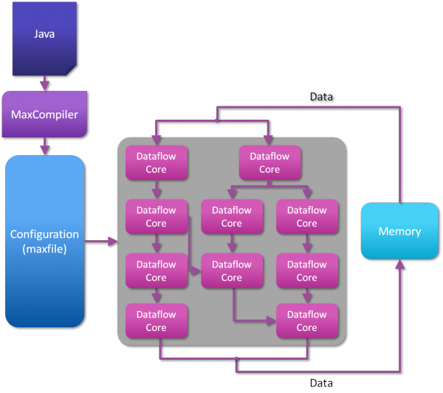
In dataflow computing, the program source is transformed into a concrete representation of the numerical algorithm ‘in hardware’. That is, a configuration file is created that describes the operations, layout and inter-connections of computational units. This configuration file is then used to realise the algorithm on a field-programmable gate array (FPGA). In contrast to the traditional control-flow computing approach, in dataflow computing the data is loaded once from memory and streamed through the entire chain of operations, thereby passing intermediate results from one computational unit to the next without writing them back to off-chip memory.
This makes dataflow computing very attractive for large-scale numerical simulations, where the main bottleneck in today’s computing devices are not the raw computational costs but the transfer of data between computational units and off-chip memory.

Problem description
The aim of this project is to apply the recently developed variational collocation method [Go16] to the Poisson equation in two and, possibly, three space dimensions and design, implement, and validate an efficient realization on Maxeler’s dataflow machines [Max]. The isogeometric analysis approach will be employed for the discretization of this elliptic PDE-problem. Higher-order B-Spline basis functions will be adopted on a multi-dimensional yet simple domain (single patch geometry). The resulting linear system of equations is very large but sparse with a regular sparsity pattern and will be solved by an iterative solution algorithm, e.g., the conjugate gradient method. Next to the efficient implementation of the variational collocation methods on Maxeler’s dataflow engines, the student will also investigate strategies for choosing the collocation points optimally.

Challenges
The challenges of this project are formulated in the following research questions:
- How to realize an efficient and accurate implementation of the variational collocation method for Poisson’s equation on dataflow machines? Matrix assembly is commonly accepted as major bottleneck in Galerkin-based isogeometric analysis, which requires the computationally costly numerical approximation of integral terms, e.g., by numerical quadrature. That’s why collocation methods, which require pointwise evaluations of the strong form of the PDE problem, have become more and more popular. The downside of collocation methods is their poor accuracy if collocation points are chosen at suboptimal locations. The variational collocation method [Go16] aims at obtaining the same accuracy as with Galerkin-based variational methods at the low computational costs of collocation methods. The goal of this master project is to investigate the potential of this novel approach on Maxeler’s DFEs.
- How to optain optimal collocation points? The theoretical foundation for the existence of optimal so-called Cauchy-Galerkin points for the variational collocation method is established in [Go16]. However, finding their optimal location is still an open research problem. Part of this project is thus to investigate different choices for the Cauchy-Galerkin points and assess their effectiveness both in terms of accuracy and wrt the limited hardware resources (LMEM) available on dataflow machines.
- How to solve the resulting linear systems efficiently on dataflow machines? The variational collocation method leads to large sparse linear systems that need to be solved, e.g., by an iterative solver. Based on a literature study on this topic the student will decide on a solution strategy (e.g., matrix-free variant of the conjugate gradient method) and develop a prototypical implementation in Maxeler’s dataflow machines. A prototypical implementation of the matrix-free Conjugate Gradient solution method on dataflow engines for unstructured FEM is presented in [Bu15] and can be used as starting point for code development in this project.

Time schedule
The following tasks are foreseen:
- Familiarization with Maxeler’s data flow computing technology and the development tools (MaxJ programming language, MaxGenFD library)
- Literature study on isogeometric analysis starting from [Hu05] with special focus on the variational collocation method [Go16] and iterative solution methods.
- Development of a variational collocation method for IgA-based discretizations of Poisson’s equation using B-Spline basis functions (reference baseline CPU code)
- Performance model analysis to identify parts of the code to be off-loaded to DFEs.
- Development of a DFE-accelerated version of the variational collocation method.
- Thesis writing.

Further information
For further information please contact Matthias Möller (m.moller@tudelft.nl) or Georgi Gaydadjiev (g.n.gaydadjiev@tudelft.nl). Access to a dedicated Maxeler server with four MAX3 dataflow engine cards will be granted. Moreover, Maxeler Technologies Ltd. offers the possibility for a short stay at its headquarter in London, UK for hands-on training. Technical support from Maxeler experts will be available during the entire project.

Literature
[Bu15] P. Burovskiy, P. Grigoras, S. Sherwin, and W. Luk, Efficient assembly for high order unstructured FEM meshes. In: Proceedings of the 25th Int. Conf. on Field Programmable Logic and Applications (2015) 1-6.
[Go16] H. Gomez and L. De Lorenzis, The variational collocation method. Comput. Methods Appl. Mech. Engrg. 309 (2016) 152-181.
[Hu05] T.J.R. Hughes, J.A. Cottrell, and Y. Bazilevs: Isogeometric analysis: CAD, finite elements, NURBS, exact geometry and mesh refinement. Comput. Methods Appl. Mech. Engrg. 194 (2005) 4135-4195.
[Max] Maxeler Technologies Inc. http://maxeler.com

